Library Name: | cgm
Cell Name: | NOR2XI
Function/Truth Table:
A B |  | Y
0 0 |  | 1
0 1 |  | 0
1 0 |  | 0
1 1 |  | 0
Propagation Delay (path based): with extracted parasitics
Transition |  | Delay (s)
A → Y ↑ (T_PLH) |  | 1.364n
A → Y ↓ (T_PHL) |  | 1.598n
B → Y ↑ (T_PLH) |  | 1.352n
B → Y ↓ (T_PHL) |  | 1.605n
Output Rise Time (path based):
Transition |  | Rise Time (s)
A → Y ↑ |  | 2.62n
B → Y ↑ |  | 2.622n
Output Fall Time (path based):
Transition |  | Fall Time (s)
A → Y ↓ |  | 3.153n
B → Y ↓ |  | 3.197n
Layout Height: 1.71µm
Layout Width: 0.8µm
Layout Area: 1.368µm²
Symbol with Port Names:

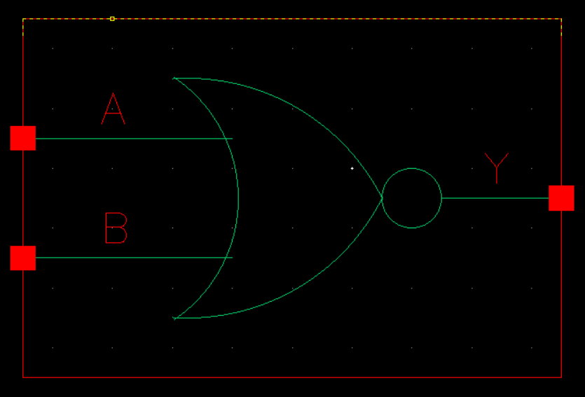
Schematic:

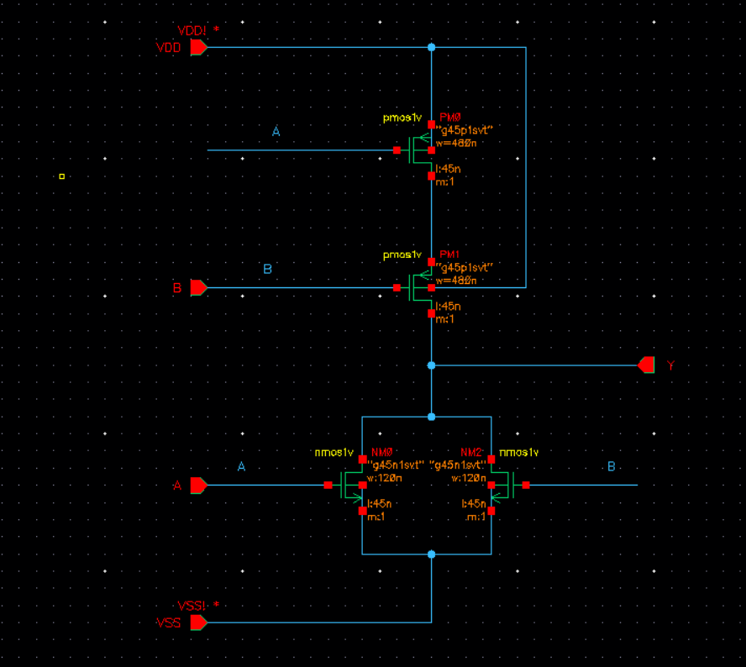
Layout:
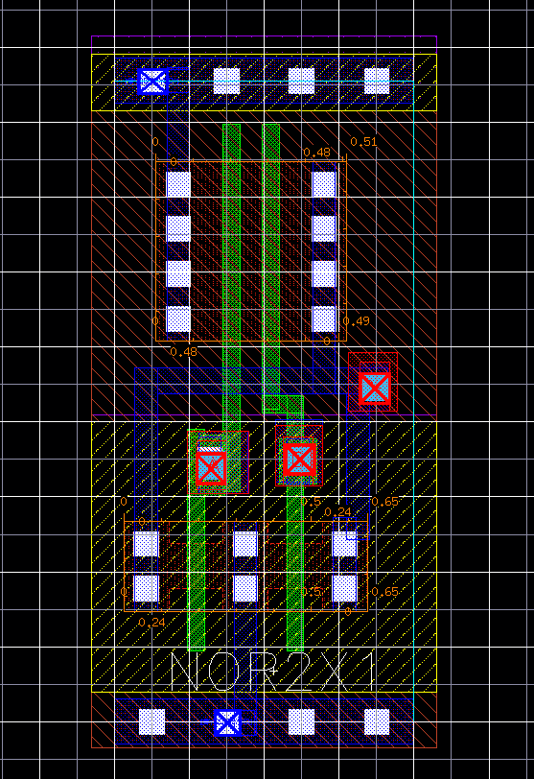
Functional Simulation Waveforms

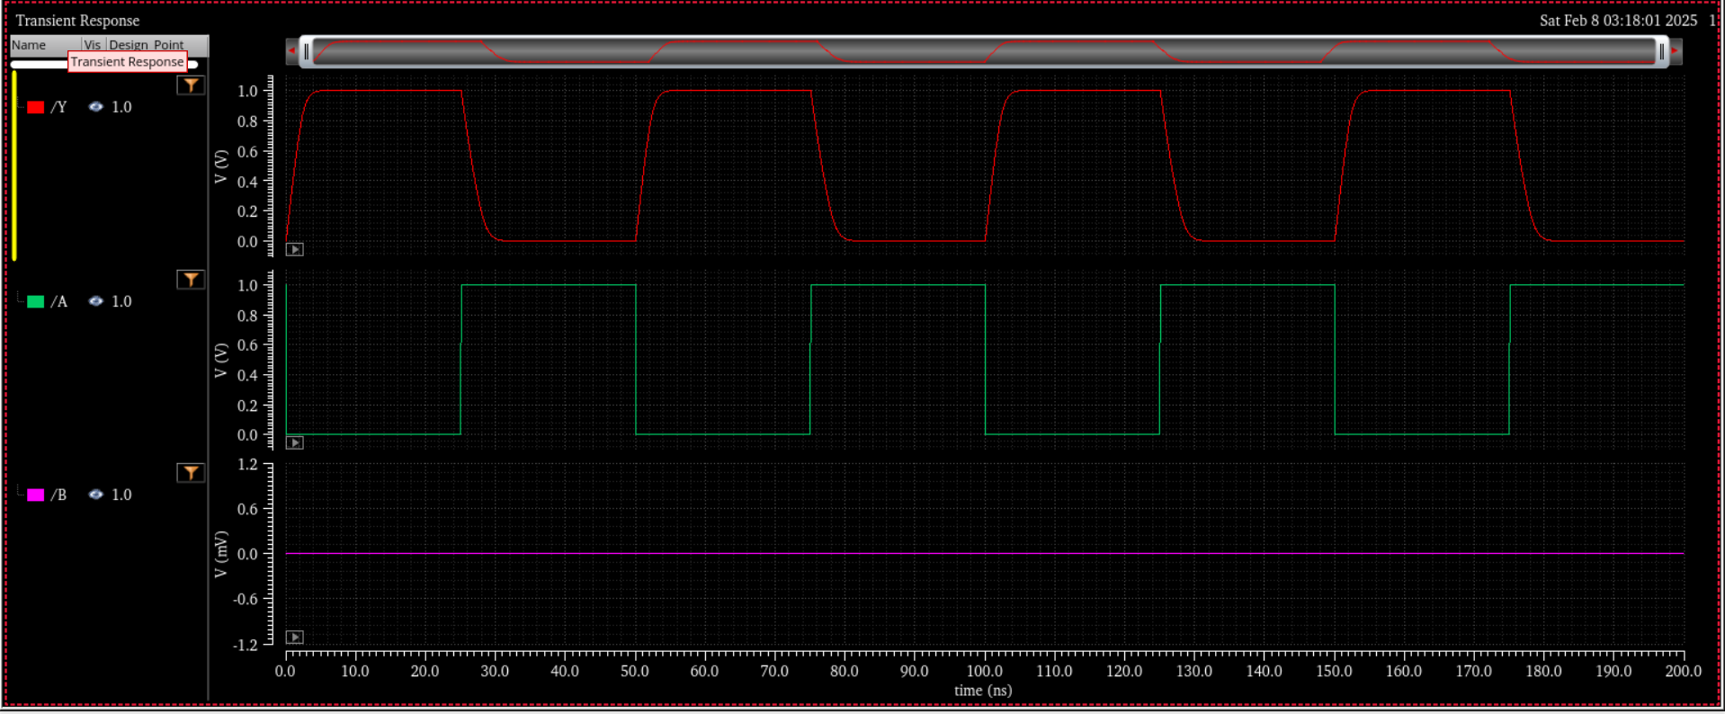

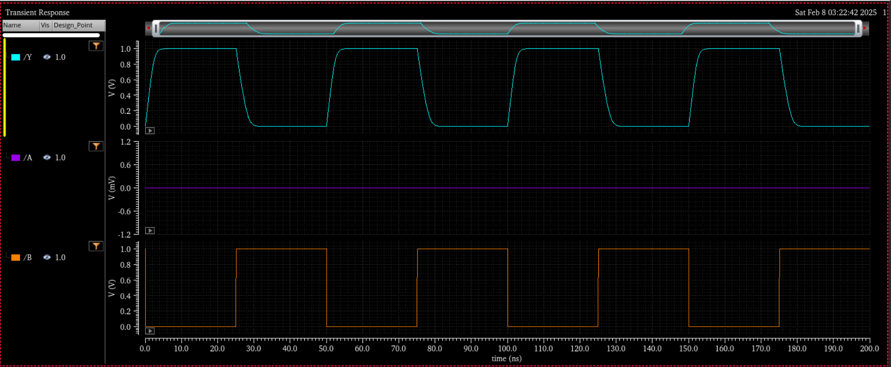

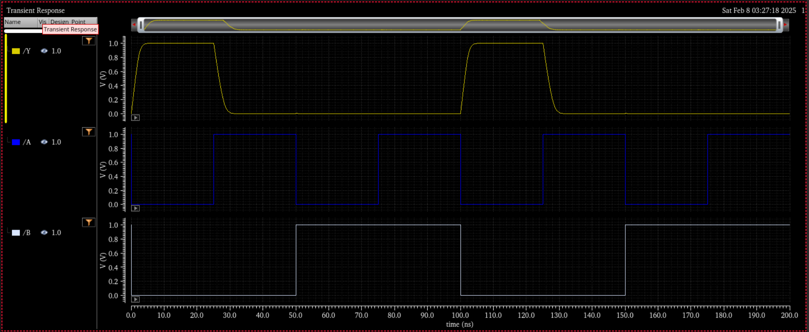
Comments/Notes:

The NOR2X1 gate with extracted parasitics was successfully tested, confirming correct functional verification. The timing results show an increase in delays compared to the pre-layout simulation, highlighting the impact of parasitic resistances and capacitances from interconnects and device structures.

